Atharva Karkar

8

MCA(DS)

* Write a program that echoes itself to stdout, but backwards

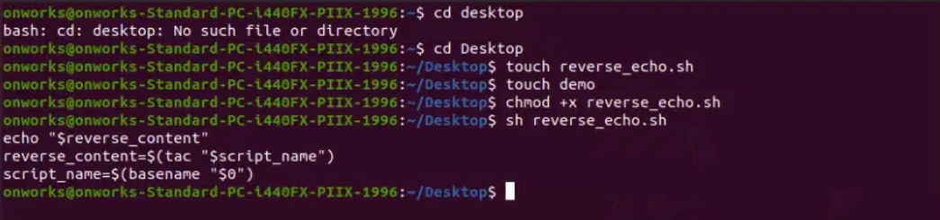

Script_name=$(basename “$0”)

Reverse_content=$(tac “$Script_name”)

Echo “$Reverse_content”